1. IntelliJ Idea allows controlling and configuring the stopping behaviour during debug session.
2. 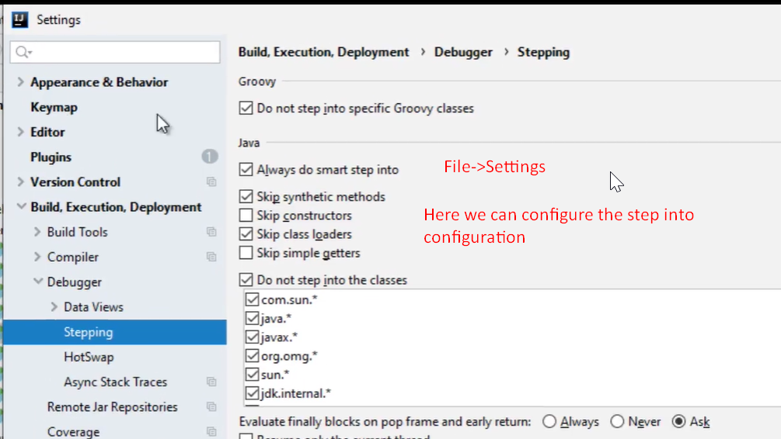
3. 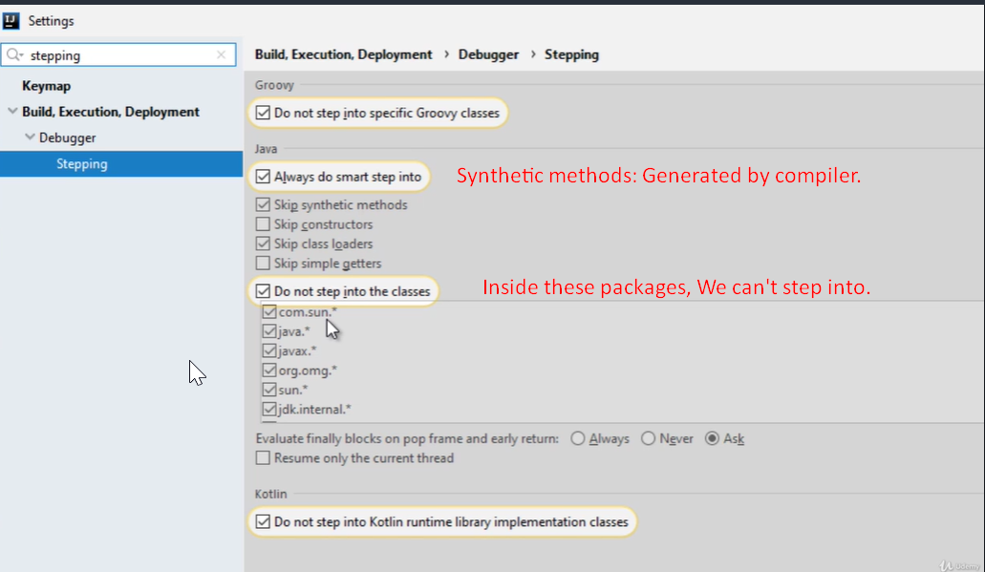
4. 